DOCUMENTING THE SHINY APP CHANGES

OK, I’ve got this thing almost working. Below I’m testing a plot where I am changing the number of STEM PhDs for any given school. It’s working correctly here…but I’m having difficulty getting the damn SEM to update…

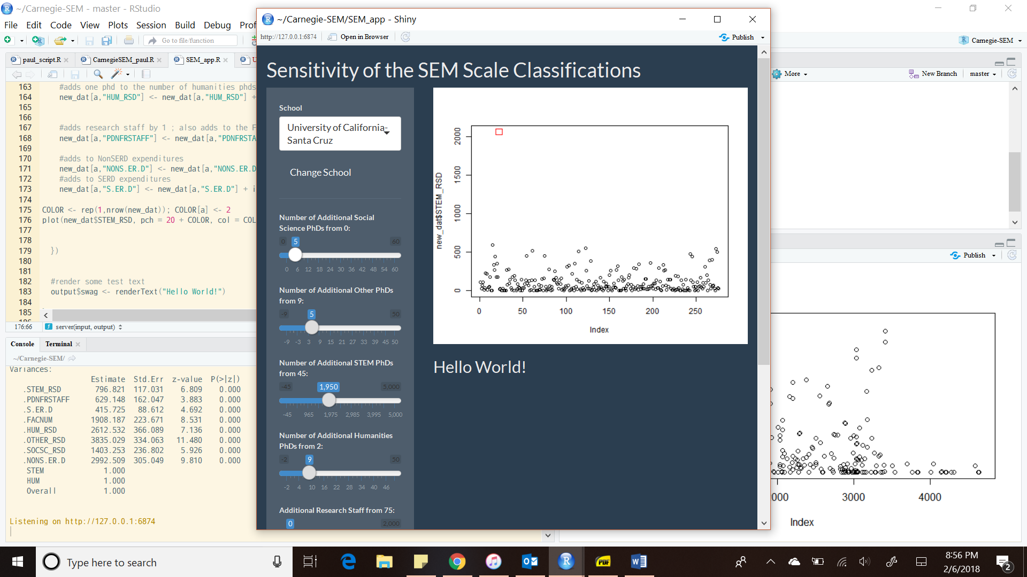

Some additional things:

* Reactive context works for the school <- pass it through and then do everything else in classPlot()
* We are able to use the sliders to change the count as well as the button to change schools.

Here’s a plot where I added an exorbitant number of research staff to Colorado State. Go Rams!

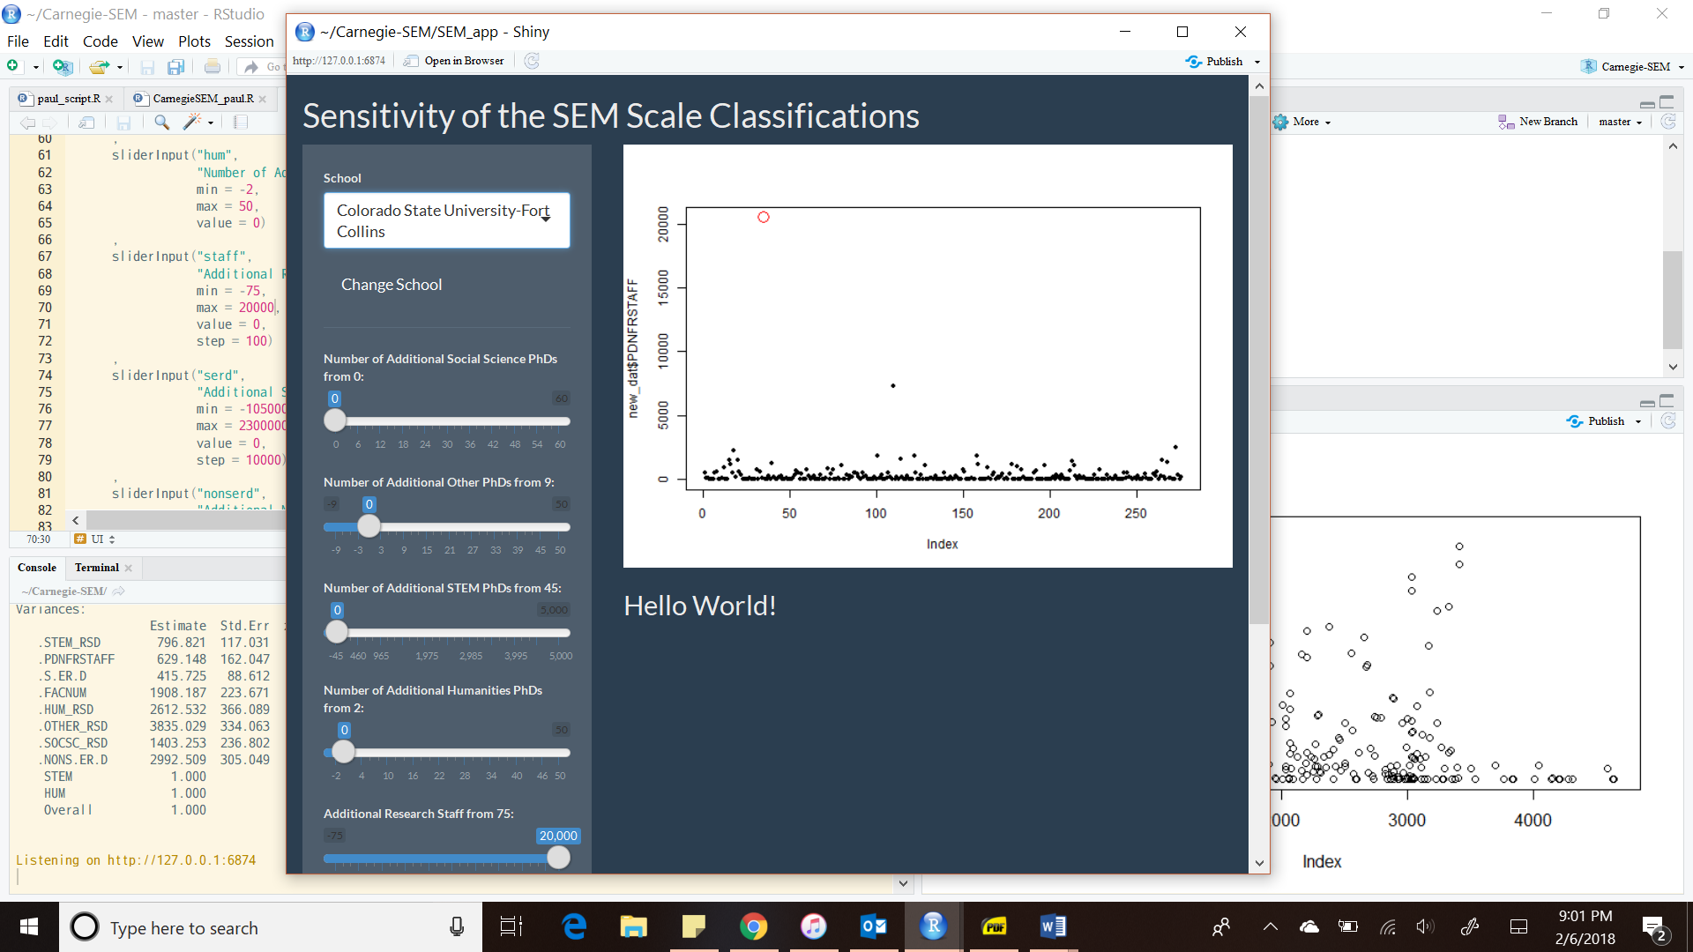

So this works just the way I am expecting it, meaning that the issue must be in the SEM code itself…